CBN RBCSF Compliance for Log360
Automate CBN RBCSF compliance and fortify cybersecurity resilience for financial institutions.
Region: Nigeria | Type: Financial Services, Cybersecurity Framework, Incident Management | Category: Compliance | Pricing: Free

Overview
The CBN RBCSF compliance extension in Log360 helps organizations meet the Central Bank of Nigeria Risk-Based Cybersecurity Framework and Guidelines (2024), CBN's mandatory cybersecurity framework for all Nigerian banks covering governance, risk management, resilience, and 24-hour incident reporting by providing centralized log management, real-time threat detection, identity monitoring, and incident response workflows. The platform supports CBN RBCSF requirements for cybersecurity governance, identity management, threat intelligence, incident reporting, network security, privileged access, and cyber resilience.
For Cybersecurity Governance and Policy Management, Log360 tracks policy modifications, configuration changes, and administrative actions to demonstrate governance accountability. To address Identity and Access Management, the platform monitors all authentication events across Active Directory, Unix, Windows, and cloud identity platforms. The extension also supports Threat Intelligence and Security Monitoring by providing capabilities that aggregates and correlates threat indicators from endpoints, network devices, and cloud sources.

Key Features
- Incident Detection and 24-Hour Reporting: Log360 provides real-time alerting on security events to support the tight 24-hour reporting window.
- Network Security and Perimeter Defense: Log360 provides unified visibility into all network device activity, firewall policy changes, and intrusion attempts.
- Privileged Access and Authentication Controls: Log360 monitors privileged activity across PAM, AD, Unix, and cloud identity platforms.
- Cyber Resilience and Business Continuity: Log360 tracks backup job status, DR policy adherence, and recovery event logs to support resilience assurance.
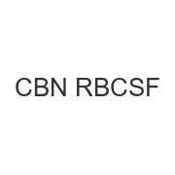
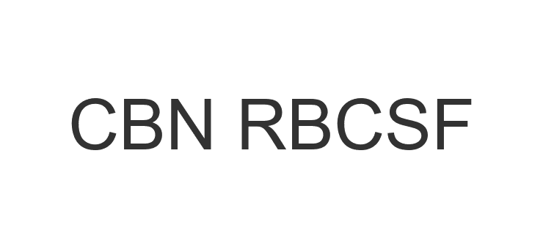
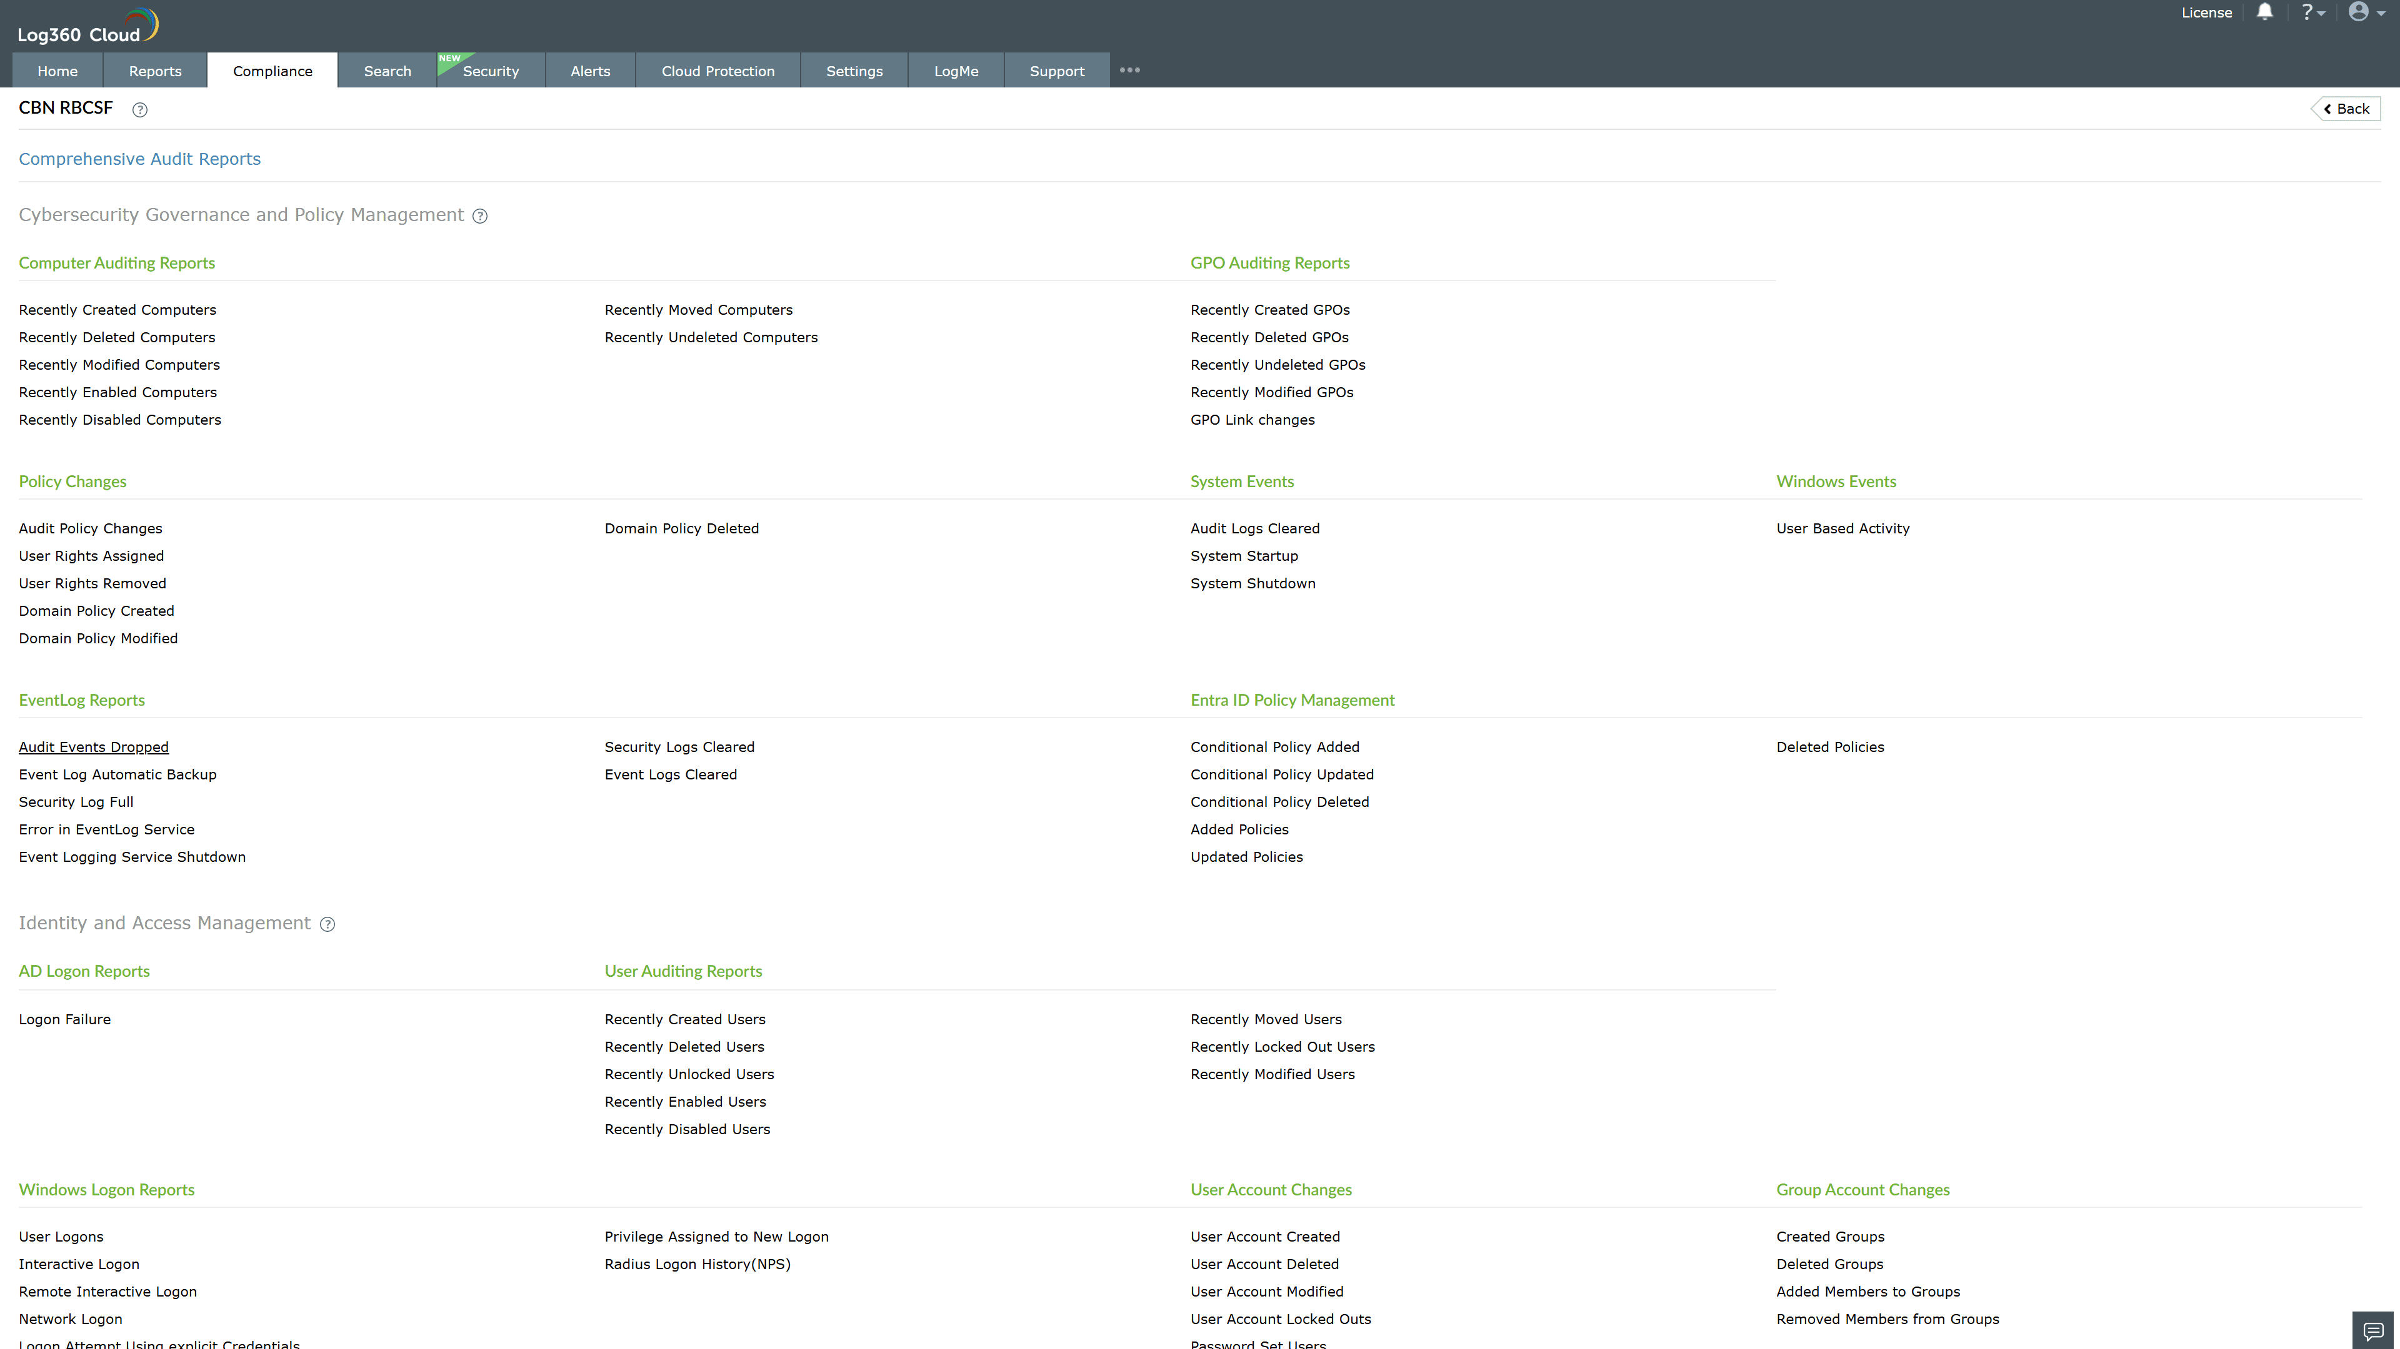
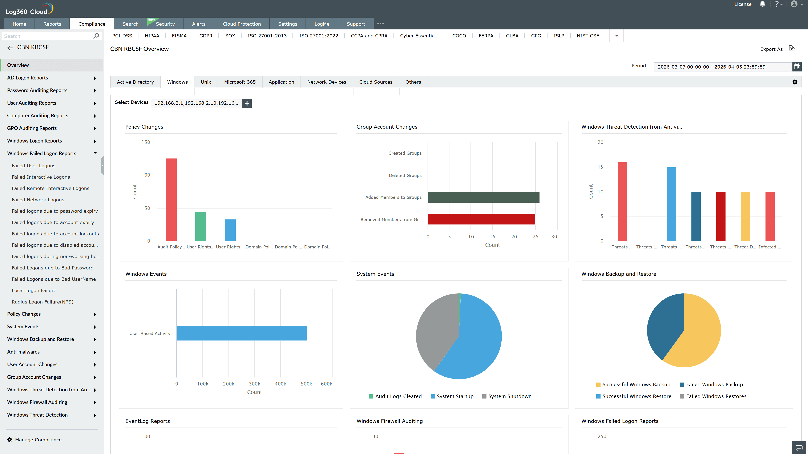
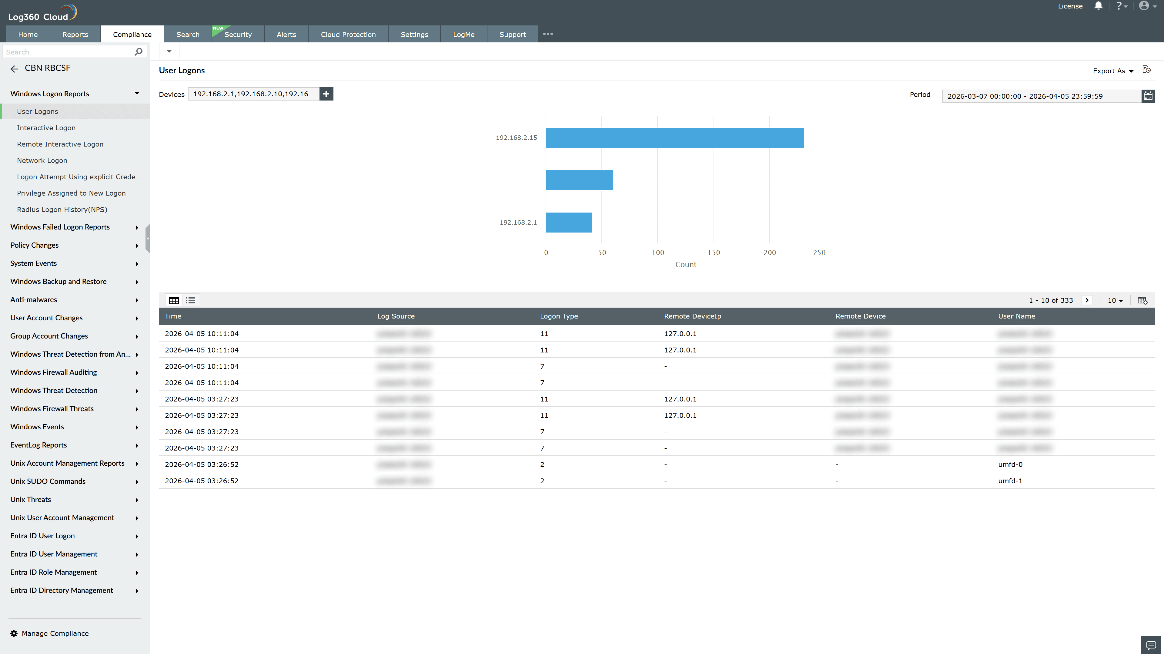
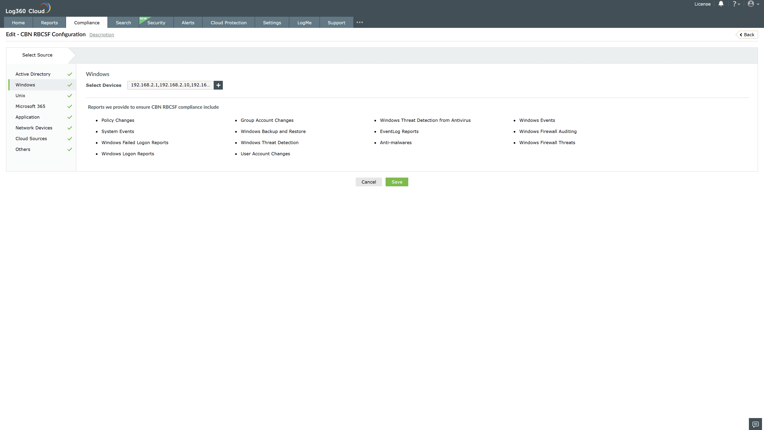
Valid Submission : Yes
Supported Editions : Free, Basic, Standard, Professional, MSSP
Help Document : https://www.manageengine.com/log-management/help/integrations/compliance-extensions.html
Help Video : Not provided
Tags : Log360, Compliance, Privacy monitoring, Data privacy, Regulatory compliance
Supported DCs : US, IN, JP, CA, AU, UK and EU
Privacy Policy:
Terms of Service:
Release Notes:
Predefined reports for the CBN RBCSF.

